Noise evaluation of the single stage
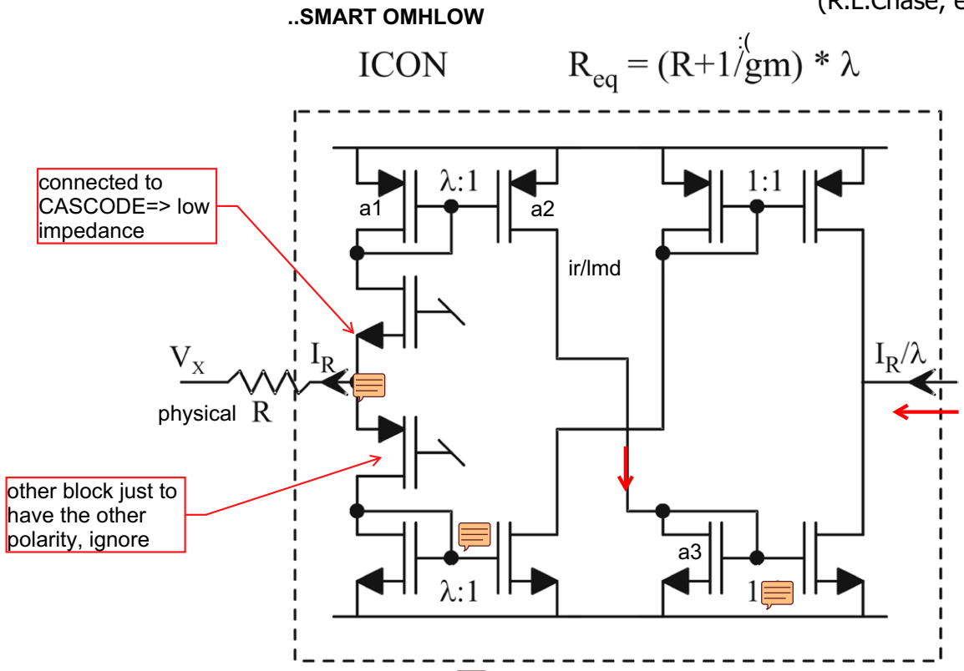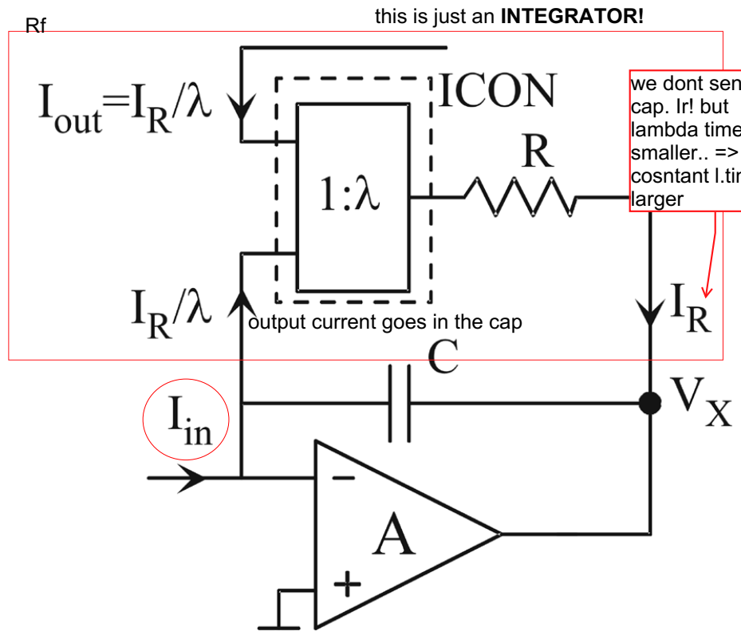
NOTA: questo è uno dei blocchi che servono per realizzare poli reali del nostro filtro.
Where the noise comes from? Let's find an electrical quantity where I focus all the noise contrib. What’s a convenient node? the input of the amplifier A.
I have Iin, which is the signal arriving from the pole/zero network. So, Iin => reference quantity where to compare the noise spectral density. Indeed all the noise coming from before will get here. We can also choose the output, and we'll just have an amplification factor [so it doesn’t really matter where we choose].

Noise contribution of the ICON
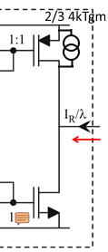
The output current is ALREADY in the right position to compare :). Let's check the current at the output of the ICON!
Last two transistor (bottom and upper) => they are already at the output. They have thermal noise of their current => ($\frac{2}{3}*4*kTgm$) (generatore di corrente in parallelo tra d-s).
How to reduce this? reduce gm. In MOSFET the gm is proportional to $√I$.
Bruteforce: I bias the last transistor with a small current. But the bias current of this is not totally independent on the current flowing in the first branch, b/c the current flowing outside is indeed $\frac{Ir}{λ}$. So reducing the current means reducing the current in the first branch. conclusion => to keep the noise low I need to bias all these circuits with a small current (in principle as small as possible).

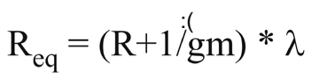
By the way, the 1/gm of the first transistor is very annoying.. if I reduce the current in input because we want to have low noise, we increase 1/gm :(. So, small current due to the noise means large 1/gm, which is a problem!! :/.
Basically the input transistors are biased really low, the 1/gm is dominated by the signal (lowering 1/gm), and that's why 1/gm is signal dependent.
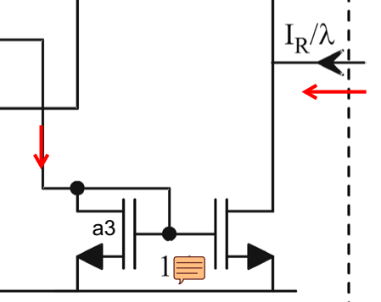
Also the other part of the mirror has the same contribution, because we have a mirroring 1:1, thus also its contribution is at the output! (noise transistor. "a3"). Non possiamo fare altro che ridurre la corrente di biasing, no altri trick.

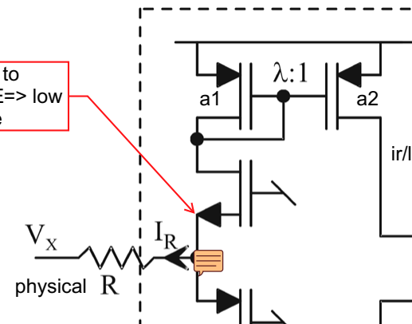
Transistor a2: same current dell'output, quindi sarà noisy uguale!

## Box
The model of thermal noise, 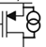 is ok only if the transistor is in strong inversion (Vg>Vt). Se riduco la corrente il transistor non sarà più in strong inversion ma in weak inversion (Vg < Vt), dove le equazioni dei transistor diventano simili a quelli del bjt. Se il transistor è biased con poca currente, ed è in weak inversion, il thermal noise perde il significato fisico e diventa shot noise, 2qI, con “I” corrente flowing in the transistor.
Conclusion ancora una volta => reducing noise can be done reducing the current. Prima la dipendenza c'era, ma era tramite $√I$. Con questo modello il noise invece è proporzionale direttamente.

######
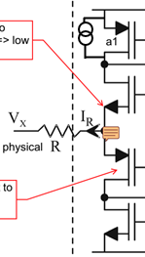
Transistor a1: large current (rispetto all’uscita). Se la corrente che fa noise in the output è I0, allora il noise spectrum dei vari transistor sarà 2qI0, il noise del transistor a1 (stessa formula, corrente diversa) è $2qλI_{0}$. Significa che a1 domina nel noise? NO, perché il transistor non è nella "final position" delle noise evaluation.
Devo trasportare il contributo fuori. Il transfer output di questo noise è: $\frac{2qλI_{0}}{λ^{2}}$ (because noise transfer, “vuole” il $TDF^{2}$). So the contribution is $\frac{2qI_{0}}{λ}$!!! :)
GOOD NEWS: even if a1 operates with ”lambda times current”, the transfer makes it negligible! THIS IS VALID FOR ALL THE TRANSISTOR IN THE INPUT. Also the first are cascode, which are INTRISICALLY NOISELESS.
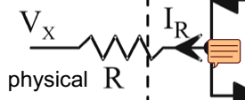
Resistor R: it's noise is $\frac{4kT}{R}$, current noise gen. in parallel to R. This gen goes into the branch, so transfer is: $\frac{4kT}{Rλ^{2}}$.

Comparison
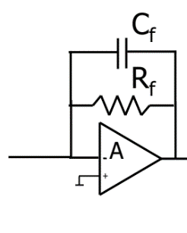
We can do a relative comparison: how is this noise compared to the noise of a traditional stage? (lo stage tradizionale che sto emulando è quello di un integratore con RfCf, no Ri). I want to make a 1:1 noise comparison, thus Rf = R*lambda => I have built on the chip a huge resistor with R*λ (ovviamente non esiste ma è concettuale).
In questo caso allora il noise current generator in parallel to R is: $\frac{4kT}{Rλ}.$

This is the noise contrib. I have at the input. But using a smart circuit, with the ICON, the noise is: $\frac{4kT}{Rλ^{2}}$
FOR THE SAME VALUE OF R IN THE FEEDBACK! With ICON technique I have a lower noise contribution!

#####

So, advantage of ICON also keeps low noise of R, name of this technique: COLD RESISTOR. [il nome viene dal fatto che è come se lo stessimo raffreddando.. p' il noise dip. da T]

